 | Year 12 ATAR Physics Unit 3 2018  TASK 7 Electromagnetism 2 & Electromagnetic  Induction 5.0%  NAME: ………………………………………………….  Data: See Data Sheet  Approx. marks shown.  MARK: _________ / 54

When calculating numerical answers, show your working or reasoning clearly. Give final answers to three significant figures and include appropriate units where applicable.
When estimating numerical answers, show your working or reasoning clearly. Give final answers to a maximum of two significant figures and include appropriate units where applicable.
Multiple Choice Questions (1 mark each)
Circle only one correct answer.

1. Four conductors of different lengths are moved through a uniform magnetic field at the
same speed. Which conductor will induce the greatest emf?

- 1 B) 2 C) 3 D) 4

2. A step-down transformer has a 500 turn primary that operates at 120 V ac.
Which of the following sets of conditions best describes the number of secondary turns
and secondary voltage of this transformer?

3. In which of the following diagrams is the secondary current greater than the primary
current?

4. In which of the following situations would the greatest emf be induced in the coil?
All changes occur in the same time interval.

Short structured questions

1. An aeroplane with a wingspan of 10.0 m is flying horizontally at a velocity of 200 m s⁻¹.
In the region the plane is flying, the Earth’s magnetic field is 2.0 x 10⁻⁴ T, at an angle of
60º to the horizontal.

What is the magnitude of emf induced across the wingtips of the plane? (4 marks)

ANS: 0.35 V

2. A transformer for a toy train set plugs into the 240 V mains supply and changes it to
12.0 V. The toy train draws 720 mA from the transformer.

- If the primary is found to consist of 360 turns of wire, how many turns will the secondary have? (2 marks)

2b) Carefully explain why the core of a
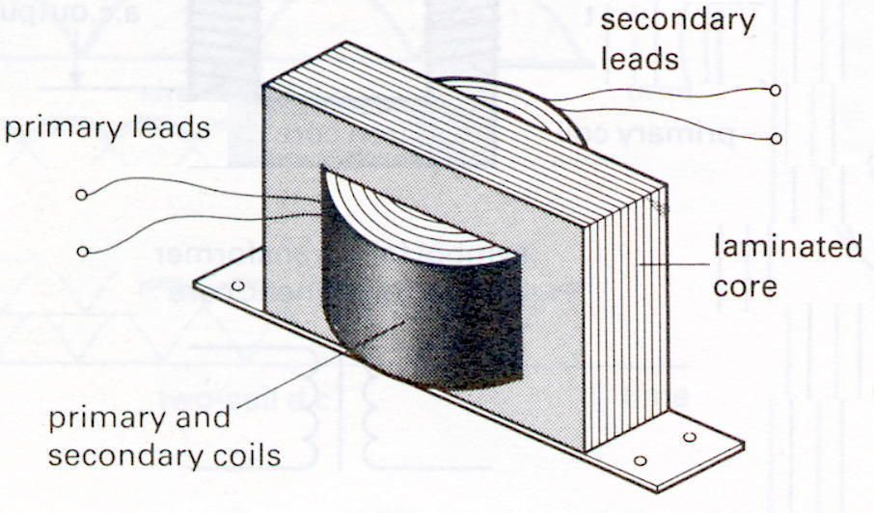
transformer consists of many thin laminated
sheets bonded together instead of a single
solid soft iron cast. (2 marks)

3. A coil is moved to the right at uniform acceleration into and out of the magnetic field.

Graph the induced current (below) as the coil moves move from position a to e with
respect to time t. (4 marks)

Assume current in a clockwise direction is considered as positive.

4. Two coils are placed side by side so that the magnetic field produced by one of the coils passes through the other.

Indicate the direction of the induced current through the galvanometer G in the secondary coil if any.

- If the switch in the primary coil has been closed for 30 seconds (1 mark)

- If the switch in the primary coil is then opened (1 mark)

5. Three rings are dropped at the same time over identical magnets as
shown below.

- Describes the order in which the rings P, Q and R (simultaneously or otherwise) reach the bottom of the magnets. (2 marks)

- Justify your answer using the relevant Physics laws. (3 marks)

6. The diagram below shows a simple AC electric generator. [15 marks]
As the loop is rotated in the magnetic field,
an emf is induced.

The graph below shows how the induced emf
varies with time.

a) Which point, A or B, could possibly
correspond to the point of rotation
shown in the diagram?

(1 mark)

A
B

b) With what speed, in revolutions per second, is the generator turning?

(1mark)

c) In a typical single phase AC generator, the average emf induced is 350 V and its
rotating coil consists of 500 turns. Find the magnetic flux (Φ) in the generator.

(4marks)

Question 6 (continued)

d) In a commercial power station, the generators have electromagnets to provide the
magnetic field.

What are some of the advantages and disadvantages of this design principle?

(3marks)

At Pinjar power station, the electricity is produced at 350 V and then stepped up to 132 kV before it is transmitted to the city.
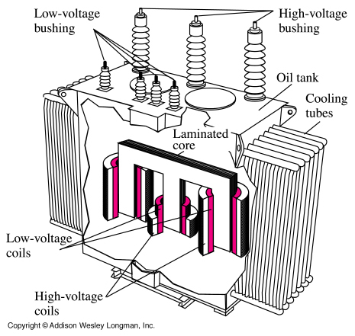

e) The transformer has an extensive cooling system
to remove the large quantities of heat produced.
Why does the transformer produce this heat?
(2marks)

f) Why is it necessary to step up the voltage before it is transmitted?

(2marks)

g) Why is electrical energy transmitted from generator to consumers using an alternating
current? (2marks)

7. During the Second World War, it was common

to guard harbours using a coil of very large area
laid across the entrance to the harbor.

This device was intended to detect the presence of a submarine by the voltage induced as the submarine passed over the harbour loop.

- Carefully explain how such a voltage might be
induced. (3 marks)

b) If, as a submarine passes, the flux passing perpendicularly through a 50 turn loop
changes at a rate of 8.00 x 10⁻³ weber per second, what emf would be induced in
the loop? (3 marks)

c) At the site of this harbour, natural variations in the vertical component of the Earth's
magnetic field might occur at the rate of 3.00 x 10 ¹⁰ tesla per second.

What is the maximum area the harbour loop must have if the naturally induced voltage is to remain below 1% of that induced by the submarine? (3 marks)

8. A rectangular conducting loop of mass 4.50 x 10⁻² kg and resistance 1.5 Ω is dropped in
the direction shown through a uniform horizontal magnetic field of 1.8 T.

Determine the speed this loop will be falling through the magnetic field when it stops accelerating? (7 marks)

END OF TEST

